Jitterbug Defined Polyhedra:
The Shape and Dynamics of Space
by
Robert W. Gray
rwgray@rwgrayprojects.com

Oct. 25-26, 2001

This presentation may be found at:
http://www.rwgrayprojects.com/OswegoOct2001/Presentation/prsentationWeb.html
Introduction
The study of the basic polyhedra is both a study in the properties of the space we live in as well as a source for basic design. Unfortunately, the relationships among the Platonic polyhedra (as well as some other basic polyhedra) are not taught as “basic knowledge” in the grade schools, nor in the Colleges and Universities. I will present an introduction to the basic polyhedra, showing how they are related to each other.
A new 120 triangular faced polyhedron will be introduced. It will be shown that this 120 Polyhedron provides a unifying vertex coordination for all of the polyhedra to be introduced.
The "Jitterbug", a dynamic polyhedron, will be demonstrated. It will be shown that the Jitterbug motion provides a dynamic means for defining these polyhedra and is, therefore, of fundamental importance to the dynamics of space itself.
The Golden ratio will be seen to occur throughout the polyhedra's relationships. This is both a fascinating "coincidence" of space as well as a visually pleasing source for basic design work.

Topics
- Review: 5 Platonic (Regular) Polyhedra
- Review: Terminology and equations
- How the polyhedra are related one to another
- Rotating cubes
- The 120 Polyhedron
- The "Jitterbug" motion
- The Jitterbug motion defines the polyhedra
- Interesting Designs
- Appendix I: Vertex Coordinates
- Appendix II: Basic Data For The 120 Polyhedron
- Appendix III: A Comment on the Golden Ratio
- Appendix IV: Planes and Common Angles Defined by the 120 Polyhedron

Review: 5 Platonic (Regular) Polyhedra

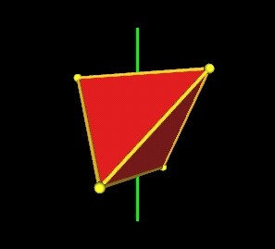 | 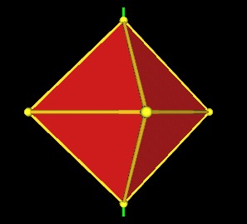
Tetrahedron | Octahedron

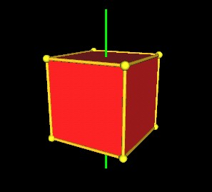
Cube

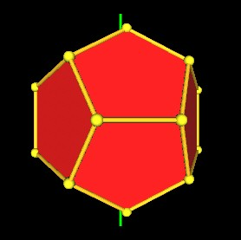 | 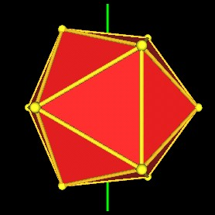
Dodecahedron | Icosahedron

Review: Terminology And Equations

n-Fold Symmetric Rotation Axes
Three kinds of symmetry rotation axes (see above illustrations for examples):
- Vertex to Vertex,
- Mid-edge to Mid-edge,
- Face to Face.

If a rotation of a polyhedron about a particular axis by an angular amount
0° < d < 360°
leaves the polyhedron in its initial position, then the axis is an n-fold symmetric rotation axis, where
n = 360° / d
and the polyhedron is said to be n-fold symmetric.
For example, the Tetrahedron's mid-edge to mid-edge axes: A rotation by 180° puts the Tetrahedron in the same positions as no rotation at all. Therefore, for this polyhedron and for this rotation axis, the Tetrahedron is 360° / 180° = 2-fold symmetric.

Allspace Filling
Neither the Tetrahedron nor the Octahedron can fill all of space, without intersection, such that
- only Tetrahedra appear in space
- only Octahedra appear in space.
The Tetrahedron and the Octahedron can combine face to face to fill all space with Tetrahedra and Octahedra.
The Cube can fill all space by itself.
Neither the Dodecahedron nor the Icosahedron can fill all space, singly or in combination.

Dual Polyhedra
To create the "dual" of a polyhedron, replace faces with vertices, and vertices with faces. (The following illustrations show the polyhedra scaled so that the dual polyhedra's edges intersect each other.)
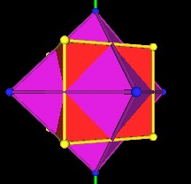 | 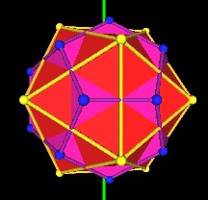
Duals: Cube and Octahedron | Duals: Dodecahedron and Icosahedron

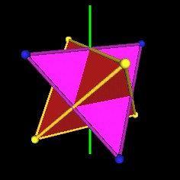
Self-Duals: Two Intersecting Tetrahedra
When scaled as shown, the Cube and Octahedron dual pair define the Rhombic Dodecahedron (shown in green). The Rhombic Dodecahedron fills all space.
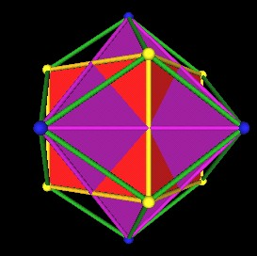
Cube and Octahedron Duals
Define Rhombic Dodecahedron
The Icosahedron and the (regular) Dodecahedron dual pair define the rhombic Triacontahedron (shown in green).
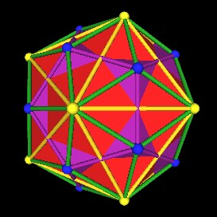
Icosahedron and Dodecahedron Duals
Define Rhombic Triacontahedron
The 2 intersecting Tetrahedra self dual pair define the Cube (shown in green).
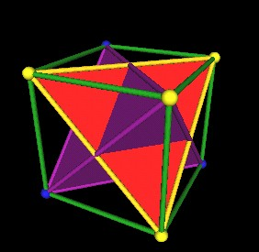
Tetrahedra Self Duals
Define Cube

Basic Equations
- Euler's Equation: V + F = E + 2
Name | Vertices | Faces | Edges | V + F | E + 2
Tetrahedron | 4 | 4 | 6 | 8 | 8
Cube | 8 | 6 | 12 | 14 | 14
Octahedron | 6 | 8 | 12 | 14 | 14
Rhombic Dodecahedron | 14 | 12 | 24 | 26 | 26
Icosahedron | 12 | 20 | 30 | 32 | 32
Dodecahedron | 20 | 12 | 30 | 32 | 32
Rhombic Triacontahedron | 32 | 30 | 60 | 62 | 62

- Sum of Surface Angles = V * 360° - 720°
Name | Sum of Angles  1 Face | Faces | Total Sum of  Surface Angles | Vertices | V*360° | V*360°-720°
Tetrahedron | 60°*3=180° | 4 | 720° | 4 | 1440° | 720°
Cube | 90°*4=360° | 6 | 2160° | 8 | 2880° | 2160°
Octahedron | 60°*3=180° | 8 | 1440° | 6 | 2160° | 1440°
Rhombic Dodecahedron | 360° | 12 | 4320° | 14 | 5040° | 4320°
Icosahedron | 60°*3=180° | 20 | 3600° | 12 | 4320° | 3600°
Dodecahedron | 108°*5=540° | 12 | 6480° | 20 | 7200° | 6480°
Rhombic Triacontahedron | 360° | 30 | 10800° | 32 | 11520° | 10800°
- Volume equations
Name | Volume Equation
Tetrahedron | 1 (Edge Length)^3
Cube | 3 (Face Diagonal)^3
Octahedron | 4 (Edge Length)^3
Rhombic Dodecahedron | 6 (Long Face Diagonal)^3
Icosahedron | 5sqrt(2)p^2(E.L.)^3
Dodecahedron | (24+42p)(E.L.^3)/sqrt(2)
Rhombic Triacontahedron | 15sqrt(2)(E.L.)^3

How The Polyhedra Are Related One To Another

Intersecting Tetrahedra In Cube
We have just seen how two intersection Tetrahedra define a cube.
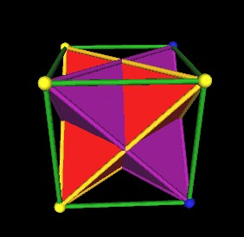
Two Tetrahedra Define a Cube

Octahedron In Intersecting Tetrahedra
The intersection of 2 Tetrahedra defines an Octahedron.
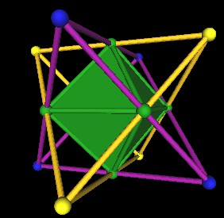
Intersecting Tetrahedra
Define Octahedron

Intersecting Cube And Octahedron Define VE
Intersecting Cube and Octahedron define a Cuboctahedron. Fuller calls the Cuboctahedron the "Vector Equilibrium" because all radial vectors from the center of volume out to a vertex is the same length as the edge vectors. This polyhedron is also called the "VE" for short.
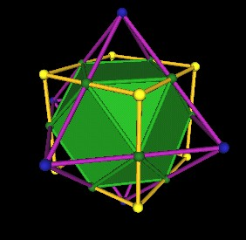
Intersecting Cube and
Octahedron Define VE

Tetrahedra In Dodecahedron
It is possible to define 10 Tetrahedra within the Dodecahedron utilizing only the vertices of the Dodecahedron.
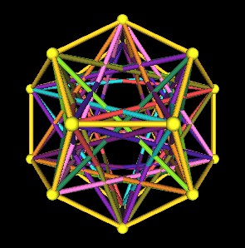
10 Tetrahedra In The Dodecahedron
Each of the Dodecahedron's vertices is shared with 2 Tetrahedra. We can eliminate this redundancy by removing 5 Tetrahedra.
5 Tetrahedra In The Dodecahedron
This suggests a spiral vortex motion in each of the Dodecahedron's faces.
5 Tetrahedra In The Dodecahedron
Suggests Spiral Motion

Cubes In Dodecahedron
It is possible to position 5 Cubes within the Dodecahedron.
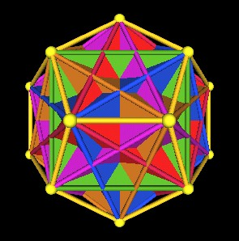
5 Cubes In The Dodecahedron

Rotating Cubes
The model of 5 Cubes in the Dodecahedron suggested to me that the cubes might be positioned within the Dodecahedron by rotations from a single cube position. This is indeed the case.
Consider a single cube. It has 4 Vertex to Vertex rotation axes.
4 Vertex to Vertex Rotation Axes
If we assign a Cube to each of these axes, we have a total of 5 Cubes (original 1 plus 4). We then rotate the 4 Cubes about these 4 axes.
Four Rotating Cubes,  One Stationary | 5 Cubes in Dodecahedron

The 120 Polyhedron
We will now put all of the polyhedra together into a single polyhedron. The resulting polyhedron will have 120 triangular faces. It is called the 120 Polyhedron.
This polyhedron was originally described to me by Lynnclaire Dennis. For more information on Ms Dennis and her work, see the Pattern web site at http://www.pattern.org/.
Start with the Dodecahedron.
Dodecahedron

Add in all 10 Tetrahedra.
Dodecahedron, Tetrahedra
Add the 5 Cubes.
Dodecahedron, Tetrahedra, Cubes

Add the duals to each of the 5 Cubes; 5 Octahedra.
Dodecahedron, Tetrahedra, Cubes, Octahedra

Recall that each Cube/Octahedron pair defines a rhombic Dodecahedron.
Dodecahedron, Tetrahedra, Cubes, Octahedra,
rhombic Dodecahedra

Add the dual to the (regular) Dodecahedron; the Icosahedron.
Dodecahedron, Tetrahedra, Cubes, Octahedra,
rhombic Dodecahedra, Icosahedron
Recall that the Icosahedron/Dodecahedron pair defines the rhombic Triacontahedron.
Dodecahedron, Tetrahedra, Cubes, Octahedra,
rhombic Dodecahedra, Icosahedron,
rhombic Triacontahedron

Connect all the outer vertices together. This defines the 120 Polyhedron.
Dodecahedron, Tetrahedra, Cubes, Octahedra, rhombic Dodecahedra,
Icosahedron, rhombic Triacontahedron, 120 Polyhedron

120 Polyhedron
(Note that there are other polyhedra with 120 triangular faces. They will not be discussed here.)

The "Jitterbug" And Its Motion
Recall the Cuboctahedron, which Fuller calls the "Vector Equilibrium" (VE).
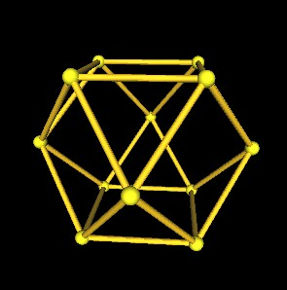
The VE

With a Cuboctahedron (VE) constructed out of sticks and rubber vertices, Fuller often demonstrated what he called the "Jitterbug" motion. The Jitterbug shows how the VE can fold up into an Octahedron as well as how an Octahedron can expand in the VE.
VE position | Jitterbug in motionJitterbug in motionBottom of Form | Octahedron position

The Jitterbug has 8 triangular faces. As these 8 faces rotate, they also move radially inward or outward from the center of volume along its 4 rotation axes.
Motion along 4 rotation axes
Top of Form
Bottom of Form
These are the same 4 rotation axes that we used to rotate the 4 cubes.
Jitterbug rotation axes

Jitterbug Motion Defines The Basic Polyhedra
Fuller pointed out that between the VE and the Octahedron positions, the Jitterbug will pass through an Icosahedron position.
Jitterbug defines
the Icosahedron
If we allow the 8 rotating triangles to interpenetrate each other, then the Jitterbug can rotate and contract into two intersecting tetrahedra to define a cube.
Jitterbug in Octahedron position | Jitterbug in motion | Jitterbug in Cube position
Further rotation and contraction results in the definition of another Icosahedron.
Jitterbug in  Cube position | Jitterbug defines  the Icosahedron | Jitterbug in  Icosahedron position
When the 120 Polyhedron is considered with all of its defining, internal polyhedra, many Jitterbugs can easily be identified. These Jitterbugs are not all in the same open position, nor of the same scale. Here is an illustration looking into the array of polyhedra through a regular Dodecahedron vertex. (The outer edges of the 120 Polyhedron are not shown.)
Looking into a
Dodecahedron vertex
In the next sequence of illustrations, I display various Jitterbugs by changing the associated polyhedron into a solid appearance. All of these Jitterbugs have the same face centered rotation axis passing through the regular Dodecahedron's vertex.
A Jitterbug in the  Icosahedron position | A Jitterbug defined by  Cube edges | A Jitterbug in the  Octahedron position

A Jitterbug in the  Tetrahedron position | A Jitterbug in the  VE position

It is difficult to see the Jitterbug defined by the Cube's edges in the above illustration, so here is a different perspective. The Dodecahedron is shown with the 5 Cubes. Some of the edges of the Cubes are outlined in black. Filling in the triangular faces in black reveals the Jitterbug.
A Jitterbug defined by the Cube edges
Notice the variation in the triangular face sizes and orientations. These variations show that there are many different Jitterbugs operating within the 120 Polyhedron.
The Octahedron is one position which the Jitterbug passes through. There are 5 Octahedra in the 120 Polyhedron. Here is a movie showing the dynamics of 5 Jitterbugs. Note that the Jitterbugs define both the Icosahedron and the Dodecahedron.
Five Jitterbugs passing
through and defining an

Icosahedron and Dodecahedron

Interesting Designs
Here are some additional combinations of polyhedra which I find particularly interesting.
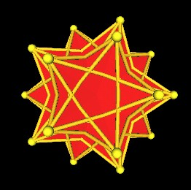 | 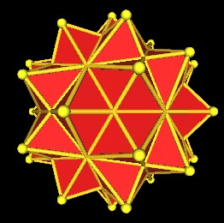 | 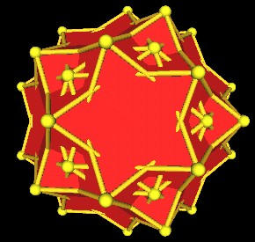
Ten Tetrahedra | Five Octahedra | Five Rhombic Dodecahedra

Five Octahedra | 5 Octahedra,  Icosahedron, Dodecahedron | 5 Octahedra,  Icosahedron, Dodecahedron

Surface waves over
the 120 Polyhedron

Appendix I: Vertex Coordinates
In order to calculate the properties of the 120 Polyhedron, it is helpful to first calculate the coordinates to its vertices. But what orientation and scale of the 120 Polyhedron should be used? Is there a preferred orientation and scale which will make calculations easier or which will highlight some important features of the 120 Polyhedron?
In a note published on "synergetics-l@teleport.com", Gerald de Jong showed that the regular Dodecahedron could be assigned simple coordinates expressed in terms of the Golden ratio. The Golden ratio is often represented by the Greek letter phi. However, I will use the letter "p" in this text. The Golden ratio is
p = (1 + sqrt(5)) / 2
which is approximately p = 1.618033989.
Gerald showed that the Dodecahedron's 20 vertices could all be assign numbers from the set
{0, -p, p, -p^2, p^2, -p^3, p^3}.
This is a remarkable set of numbers. For example, it can easily be shown that
p + p^2 = p^3
In general, it can be shown that (for n an integer)
p^n + p^(n+1) = p^(n+2)
Additionally, using these numbers for the coordinates of the regular Dodecahedron highlights the Golden ratio aspects of the polyhedron.
Since the regular Dodecahedron's vertices are the same as 20 of the 120 Polyhedron's vertices, I will use Gerald's 20 coordinates to fix the orientation and scale of the 120 Polyhedron. I will then calculate and fill in the remaining 62-20=42 coordinates.
120 Polyhedron’s Vertex Coordinates
  Vertex | Type | X | Y | Z
  1 | A | 0 | 0 | 2p^2
  2 | B | p^2 | 0 | p^3
  3 | A | p | p^2 | p^3
  4 | C | 0 | p | p^3
  5 | A | -p | p^2 | p^3
  6 | B | -p^2 | 0 | p^3
  7 | A | -p | -p^2 | p^3
  8 | C | 0 | -p | p^3
  9 | A | p | -p^2 | p^3
  10 | A | p^3 | p | p^2
  11 | C | p^2 | p^2 | p^2
  12 | B | 0 | p^3 | p^2
  13 | C | -p^2 | p^2 | p^2
  14 | A | -p^3 | p | p^2
  15 | A | -p^3 | -p | p^2
  16 | C | -p^2 | -p^2 | p^2
  17 | B | 0 | -p^3 | p^2
  18 | C | p^2 | -p^2 | p^2
  19 | A | p^3 | -p | p^2
  20 | C | p^3 | 0 | p
  21 | A | p^2 | p^3 | p
  22 | A | -p^2 | p^3 | p
  23 | C | -p^3 | 0 | p
  24 | A | -p^2 | -p^3 | p
  25 | A | p^2 | -p^3 | p
  Vertex | Type | X | Y | Z
  26 | A | 2p^2 | 0 | 0
  27 | B | p^3 | p^2 | 0
  28 | C | p | p^3 | 0
  29 | A | 0 | 2p^2 | 0
  30 | C | -p | p^3 | 0
  31 | B | -p^3 | p^2 | 0
  32 | A | -2p^2 | 0 | 0
  33 | B | -p^3 | -p^2 | 0
  34 | C | -p | -p^3 | 0
  35 | A | 0 | -2p^2 | 0
  36 | C | p | -p^3 | 0
  37 | B | p^3 | -p^2 | 0
  Vertex | Type | X | Y | Z
  38 | C | p^3 | 0 | -p
  39 | A | p^2 | p^3 | -p
  40 | A | -p^2 | p^3 | -p
  41 | C | -p^3 | 0 | -p
  42 | A | -p^2 | -p^3 | -p
  43 | A | p^2 | -p^3 | -p
  44 | A | p^3 | p | -p^2
  45 | C | p^2 | p^2 | -p^2
  46 | B | 0 | p^3 | -p^2
  47 | C | -p^2 | p^2 | -p^2
  48 | A | -p^3 | p | -p^2
  49 | A | -p^3 | -p | -p^2
  50 | C | -p^2 | -p^2 | -p^2
  51 | B | 0 | -p^3 | -p^2
  52 | C | p^2 | -p^2 | -p^2
  53 | A | p^3 | -p | -p^2
  54 | B | p^2 | 0 | -p^3
  55 | A | p | p^2 | -p^3
  56 | C | 0 | p | -p^3
  57 | A | -p | p^2 | -p^3
  58 | B | -p^2 | 0 | -p^3
  59 | A | -p | -p^2 | -p^3
  60 | C | 0 | -p | -p^3
  61 | A | p | -p^2 | -p^3
  62 | A | 0 | 0 | -2p^2

Remember that the 10 Tetrahedra, 5 Cubes, 5 Octahedra, 5 rhombic Dodecahedra, the regular Dodecahedron, Icosahedron and the rhombic Triacontahedron all share their vertices with the 120 Polyhedron. This means that all their vertex coordinates are a subset of the coordinates given above.
The combinations of 0, p, p^2, p^3 is very interesting.

Appendix II: Basic Data For The 120 Polyhedron
Using the above coordinates, the basic data for the 120 Polyhedron can easily be calculated.
The 120 Polyhedron has 3 types of vertices. Each type of vertex is defined by the other polyhedra that share the vertex.
Vertex types

Vertex  Type | Shared With The Vertices Of
A | Octahedra, Rhombic Dodecahedra
B | Icosahedron, Rhombic Triacontahedron
C | Regular Dodecahedron, Rhombic Dodecahedra, Cubes,  Tetrahedra, Rhombic Triacontahedron

The 3 different vertex types of the 120 Polyhedron are at different distances from the Polyhedron's center of volume.
Vertex  Label | Radius | Approx.
A | 2p^2 | 5.236067977
B | sqrt(2+p)p^2 | 4.97979657
C | sqrt(3)p^2 | 4.534567884

The edge lengths of the triangular face ABC are
Edge | Length | Approx.
AB | sqrt(3)p | 2.802517077
AC | sqrt(2+p) | 1.902113033
BC | sqrt(2+p)p | 3.077683537

The face angles are calculated to be
Angle  Label | Angle | Approx.
BAC | arccos(1/(sqrt(6+3p)p)) | 79.18768304°
ABC | arccos((p^2)/sqrt(6+3p)) | 37.37736814°
ACB | arccos(p/(2+p)) | 63.43494882°

The triangular face data is summarized in the following diagram.
Triangle Data

In calculating the volumes of the polyhedra in the 120 Polyhedron, I will use, as Fuller does, the Tetrahedron as unit volume.
Polyhedron | Coordinate  Distance | Normalized  Length | Volume | Approx.
Tetrahedron | Edge  2sqrt(2)p^2 | 1 | 1 | 1.0
Cube | Face Diagonal  2sqrt(2)p^2 | 1 | 3 | 3.0
Octahedron | Edge  2sqrt(2)p^2 | 1 | 4 | 4.0
Rhombic  Dodecahedron | Long Face Diagonal  2sqrt(2)p^2 | 1 | 6 | 6.0
Regular  Dodecahedron | Edge  2p | 1/(sqrt(2)p) | (3/2)(2+p) | 5.427050983
Icosahedron | Edge  2p^2 | 1/sqrt(2) | (5/2)p^2 | 6.545084972
Rhombic  Triacontahedron | Long Face Diagonal  2p^2 | 1/sqrt(2) | 15/2 | 7.5
120 Polyhedron | Long Face Diagonal  of R. Triaconta. 2p^2 | 1/sqrt(2) | 15/p | 9.270509831

It is interesting to note that in the 120 Polyhedron, the Icosahedron edge length is equal to the Cube edge length. The Icosahedron edge length is also equal to the distance from the center of volume to an Octahedron vertex.

Appendix III: A Comment on the Golden Ratio
The Golden Ratio occurs quite frequently in biology. Many growth patterns exhibit the Fibonacci numbers (1, 1, 2, 3, 5, 8, 13, 21, etc.) in which the next number is the sum of the previous 2 numbers. The Fibonacci sequence is known to be connected with the Golden Ratio.
Although it is often pointed out that the Golden Ratio is the limit of successive Fibonacci numbers
Lim(n->infinity) (f(n+1)/f(n)) = p
this is also true for any sequence f(n) defined by
f(n+1) = f(n) + f(n-1)
where f(n) is an integer for all n. The Fibonacci sequence (1, 1, 2, 3, 5, 8, 13, etc.) is just one such sequence. Any sequence as defined above will work.
The important point is that the Golden Ratio is not exclusively associated with the Fibonacci sequence, as many writings might lead you to believe.
For example, try f(1)=-23, f(2)=15, then f(3)=-8, f(4)=7, f(5)=-1, f(6)=6, f(7)=5, f(8)=11, f(9)=16, f(10)=27, etc. Then the limit as n approaches infinity of f(n+1)/f(n) will equal the Golden Ratio. (f(10)/f(9)=27/16=1.6875 which already starts to show the 1.6... of the Golden Ratio.)
So the Golden Ratio is connected with how the series is constructed and not a particular example of that construction (i.e. the Fibonacci sequence.) The Fibonacci sequence happens to be the most well known example of the construction rule
f(n+1) = f(n) + f(n-1)

Appendix IV: Planes and Common Angles Defined by the 120 Polyhedron
Returning to consider the coordinates of the 120 Polyhedron's vertices as listed above, it is obvious, from the z-coordinate, that the 62 vertices divide themselves into 9 groups. Each group defines a plane passing through the polyhedron. The spacing between the planes is shown in the next illustration.
Vertex layers in the 120 Polyhedron

The central angles of the intersection of these planes with a circumsphere are given in the next table The results illustrate interesting relations between the angles and the Golden Ratio p. The radius of the sphere is 2p^2 = 2 + 2p.
cos(18°) | sqrt(2+p)/2 | sin(72°)
cos(30°) | sqrt(3)/2 | sin(60°)
cos(36°) | p/2 | sin(54°)
cos(45°) | 1/sqrt(2) | sin(45°)
cos(54°) | sqrt(3 - p)/2 | sin(36°)
cos(60°) | 1/2 | sin(30°)
cos(72°) | 1/(2p) | sin(18°)

Central Angles of Planes

Additional Angles

However, as pointed out above, not all of the 120 Polyhedron's vertices are at the same radial distance from the center of volume. This means that not all of the vertices lie on the circumsphere. I am only illustrating the planes defined by these vertices and not the vertices themselves.

